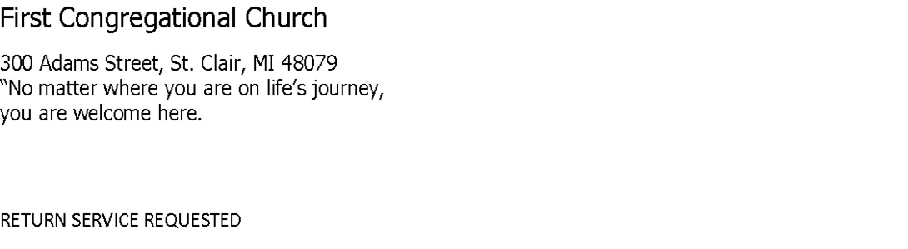

The Channel
A monthly publication of First Congregational Church of St. Clair, UCC
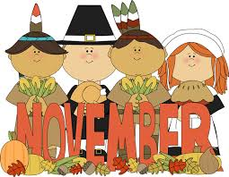
2022

Some Thoughts from Pastor Alana November 2022

Mark 4:39-40
“[Jesus] got up, rebuked the wind and said to the waves, “Quiet! Be still!” Then the wind
died down and it was completely calm. He said to his disciples, “Why are you so afraid?
Do you still have no faith?”

Greetings, and Peace to You!
Hasn’t this Autumn been just perfect? It is so beautiful when the leaves have
changed and then finally begin to fall from the trees. And the sky seems grayer, which
makes the colors appear that much brighter.
On Sunday I spoke with the children about how our seasons change and we all
agreed that we love each one. And I allowed as how even though the seasons change,
God’s love for us never changes. And during difficult times we can always reach out to
God in prayer. God will be there for us because we are God’s children and God loves us
with a constant love.
When a pastor leaves a church, it makes people nervous. When it’s time for this
sort of change, church members can get antsy; become fearful. And this is
understandable.
We’ve settled into a pretty nice routine together here at First Congregational
UCC St Clair. By this time, at almost seven years together, you know what to expect of
me and I know what to expect of you. Thinking about what the future might have in store
can be stress-inducing. BUT, it can also be very exciting.
New servant leaders will be coming here, full of energy and compassion. They will want to do what is best for each of you and for the church, this congregation.
First an Interim Minister will come and then the settled minister the church calls will
come. They will each bring new life and energy to the church.
Getting to know them will be like opening a gift as layers of wrapping paper are
torn away and more and more of this new person will be revealed to you. And you as a
congregation will be revealed to them.
One of the difficult parts of leaving St Clair for me is that there is an expectation
of me that I will maintain healthy boundaries from the church after I’m gone. I know this
well because I taught Boundary Training for Pastors in the Ohio Conference Western
Reserve Association. This separating is extremely difficult for a pastor just as it will be
extremely difficult for some of you.
Important life events that occur after I’ve gone, like weddings, graduations and
funerals, will be for your new pastor to officiate, to celebrate with you during happy
times, to mourn with you through difficult times. These important events along with
Sunday worship, pastoral care, book studies and attendance at meetings allows you as
congregation members to get to know and to care for your new pastor.
It may feel uncomfortable for some of you that I am less responsive than would be ideal. But, even as I leave I will be ministering to you as I separate myself from you, so that you are able to quickly develop faith in your Interim Minister and then your settled pastor.
Seasons come and seasons go. And the seasons I’ve spent with you have been
heaven on earth to me. I can’t express in words the care I have for each of you, even
those who have pulled away over the years. But, the fact is that YOU are the constant
at First Congregational UCC St Clair. Pastors come for a season and then move on in
their lives, called away by God.
This is exactly as it should be. God is truly with you, and the Holy Spirit will assist
you in finding your next pastor. The Holy Spirit will be with you as you do the work required to welcome your new pastor. Departures are always sad. But, as this next chapter is opened to you, I hope you will be able to be as excited for this body, this church, as I am for all of you.

With You on the Journey,

Pastor Alana.

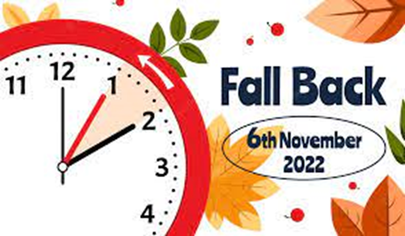

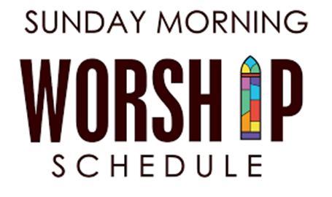
November 2022
Sunday Steward Communion
Tom Pennewell Cathy Light

Lay Readers
11/6 – Bonnie Landschoot
11/13 – Rose Crowley
11/20 – Marge Guinther
11/27 – Nancy Rice

Power Point
11/6 – Jody Skonieczny
11/13 – David Kelley
11/20 – Pat O’Connor
11/27 – Ash Currie

Usher Teams
11/6 – Bob Rood & Karen Galvin
11/13 – Dave Scheel & Tom Pennewell
11/20 – Don Rice & Tim Galvin
11/27 – Cal Eschenburg & Paul Lydy

Facebook – Livestream
11/6 - David Kelley
11/13 – Kathy Cilluffo
11/20 – Don Rice
11/27 – David Kelley

BIBLE STUDY IS BACK
Bible Study in the Lounge at 10:30 on Wednesday mornings. We’ll meet to discuss our favorite passages; passages that we find perplexing, and we’ll discuss what was going on in the world at the time those passages were written. Learn about this
book we rely on so heavily!
PLEASE COME!

Wendy is out of the office
November 14th thru November 18th.
She will return to the office
Monday, November 21st.
The office will be closed on Thanksgiving day.
Normal office hours will resume
November 29th:
Tuesday – Friday
9 a.m. – 2 p.m.

Stewardship Sunday is
November 20th,
Pledge Forms will be located on
the back table in the sanctuary.
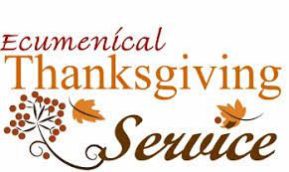

First Congregational Church of St. Clair
will host a
Thanksgiving Ecumenical Worship Service
with
St. Peter’s Lutheran
and
Holy Family
on
Tuesday,
November 22, 2022, 7 p.m.

Erin &Tim Galvin, Jr.

Kaylie O’Connor 11/03
Ann Whittaker 11/10
Michele Baden 11/11
Carlos Arevalo 11/12
Kenneth Gregg 11/12
Elsa Pennewell 11/16
David Kelley 11/22
Rachel O’Connor 11/22
Nancy Rice 11/27
Michael Malcolm 11/30

WELCOME
TRACY

ARE YOU THINKING ABOUT
CHURCH MEMBERSHIP?

If you’re interested in learning about becoming a church member, Pastor Alana will provide information about the United Church of Christ and this church specifically.

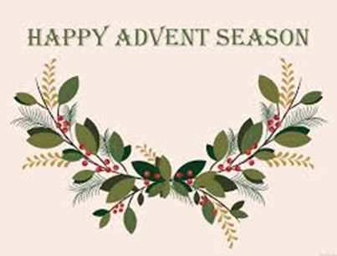

As Advent season approaches there will be flower offering envelopes on the back table of the sanctuary to purchase
Poinsettias for the church.
You may also contact Bev Stewart at
(810) 329-2147 or (810) 300-2664

THE LITTLE RED FOOD PANTRY
This small pantry is a community outreach program sponsored by The Mission Team of this church. It is stocked twice-weekly with non-perishable food. Donation requests may change but the need to feed does not.

November nights
bring rainy days.
And sometimes hunger…
a feeling that stays.

Holiday hunger
hurts more
when it’s hidden
behind a closed door.

Give thanks
by giving
for the life
you are living.

Please leave your food donations in the elevator room on the shelves labeled
THE LITTLE RED FOOD PANTRY.
Any questions…..just call Nancy Kennedy at (810)-329-3790.

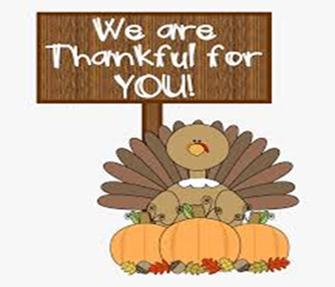

The Sanborn Gratiot Memorial Home, Inc. provides residential assisted living for the elderly with a mission to serve lower income
seniors who are semi-independent and seeking a secure and affordable residence. It is located on 2732 Cherry Street in Port Huron. The home was founded in 1944 by five Christian women with generous financial support from others in the community.
During the month of November, the Mission Team would like to collect items for Bingo prizes and personal care. The following items are suggested.
Small packages of snacks/cookies, lotion, crossword puzzle books, figurines, small puzzles, notebooks, pens, calendars etc. There is a tray of items in the elevator room. Items brought to the church can be added to the shelf. These will be given to the home at the end of November.
Thank you for supporting this Mission project.

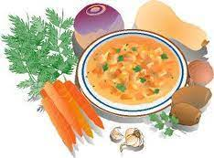

WINTERIZING YOUR DIET
Winterizing your diet can be healthy and tasty and if you add a few favorite cold weather foods.

FOODS YOU SHOULD EAT THIS WINTER

ROOT VEGETABLES
Beets, carrots, turnip…you will get valuable beta-carotene, Vitamin C and A. They are also available during the winter months, roast your carrots, boil the turnips.

VITAMIN D RICH FOODS
Shiitake mushrooms, salmon, egg yolks, fortified cereals, milk, red meat. Vitamin D foods reduce anxiety and depression.

OATMEAL
Old fashioned oats have many needed nutrients, increased zinc, soluble fiber which all help with healthy immune functions.

SOUPS
Soups without salt and cream. Soups with beef – chicken broth, vegetable broth, water based soup, include lots of vegetables and add beans and lentils for fat free protein and fiber.

SNACKS
Snacks for your immune system increase your intake of Vitamin C: oranges, mangos, lemons, kiwis, broccoli, bell peppers, strawberries. Fresh or frozen cauliflower and broccoli are high in Vitamin C and enhance your immune system.

REASONS FOR THE FLU SHOT
The vaccine prevents illnesses, medical visits, hospitalizations and death. The flu shot is an important preventative tool for people with chronic health conditions. The flu vaccine protects pregnant women from flu/hospitalization and is shown to protect the baby. A 2017 study showed the flu vaccine can be life saving for children. Some people who get the vaccine still get sick, the flu vaccine reduces the severity of illness.
WHY DO YOU GET A FLU VACCINE YEARLY
Flu viruses are constantly changing – vaccines are updated to which flu virus will be common during the upcoming flu season. Your protection declines over time. Yearly protection is needed for the best protection.
The CDC recommends everyone over 6 months and older get annual flu vaccines.

COVID 19 ST. CLAIR COMMUNITY
LEVEL IS MEDIUM
This number was calculated 10/18/22.
RECOMMENDATIONS
Get tested if you have symptoms,
wear a mask if you have symptoms
or are positive.
You may chose to wear a mask at anytime to protect yourself and others.
Get vaccinated – Get Booster Shots.
Shots are readily available at MD offices, Health Department, Pharmacies, Meijers.
Questions??
Call the CDC 1-800-232-4636

